D605 Task 3 - Optimization
By: Staphon Smith

A. Optimization Program Problem:
Please refer to this submission that includes the program used to run this optimization in Python.
A1. Demonstrate Solver Solution

Here is the solution given by the program:

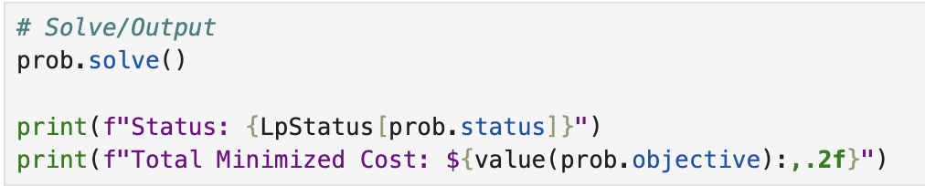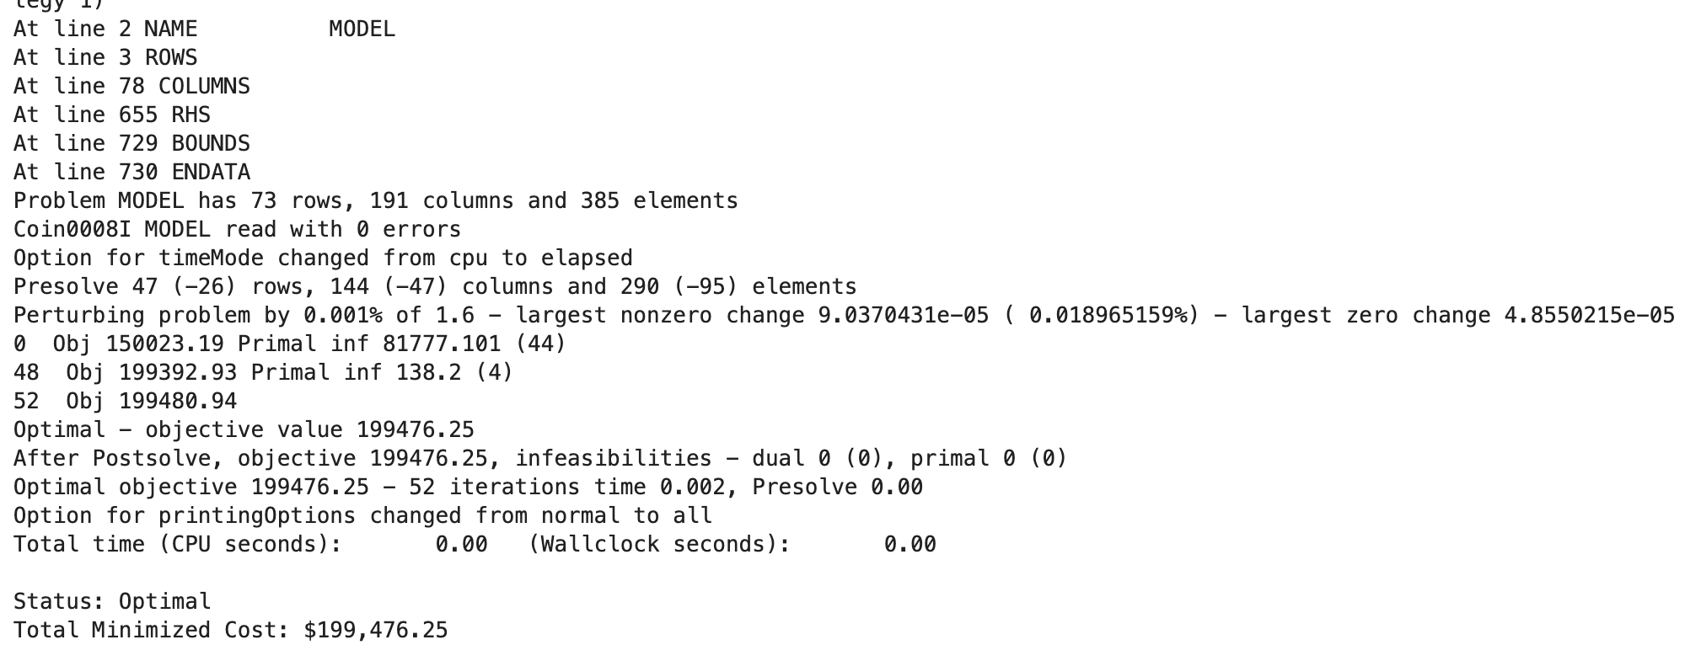

The Python script successfully translated my mathematical model into code:
Variables: The script defined and calculated values for all three route types: direct from hubs ($y$), via focus cities ($x$), and from focus cities to centers ($z$).
Objective: The solver successfully minimized the total cost function, finding an optimal monthly transportation cost of $199,476.25.

B. Output Analysis

B1:Satisfying Optimization Problem Constraints

My code output confirms that the optimization model successfully followed all the boundaries I established in Task 2.
Hub Capacities:
The model respected the monthly limits for both US hubs.
- CVG (Cincinnati): The solution used 95,650 tons, which is exactly 100% of the hub's capacity. This shows that CVG is a "bottleneck" in the current network; the system maxed it out to keep costs low.
- AFW (Fort Worth): The model used 38,097 tons out of the available 44,350 tons. This leaves about 6,253 tons of slack, meaning the constraint was satisfied without hitting the limit.
Flow Conservation:

The model correctly balanced the cargo moving through Focus Cities.

- Leipzig: The script shows 43,470 tons entering Leipzig and exactly 43,470 tons leaving it. This proves that no cargo was lost in transit ($\text{Inflow} = \text{Outflow}$).
- Hyderabad & San Bernardino: Both had zero flow, which mathematically satisfies the constraint since $0 = 0$.
Center Demand:

I verified that every fulfillment center received the exact amount of cargo requested. For instance, Paris received its required 6,500 tons and Bengaluru received 9,100 tons.

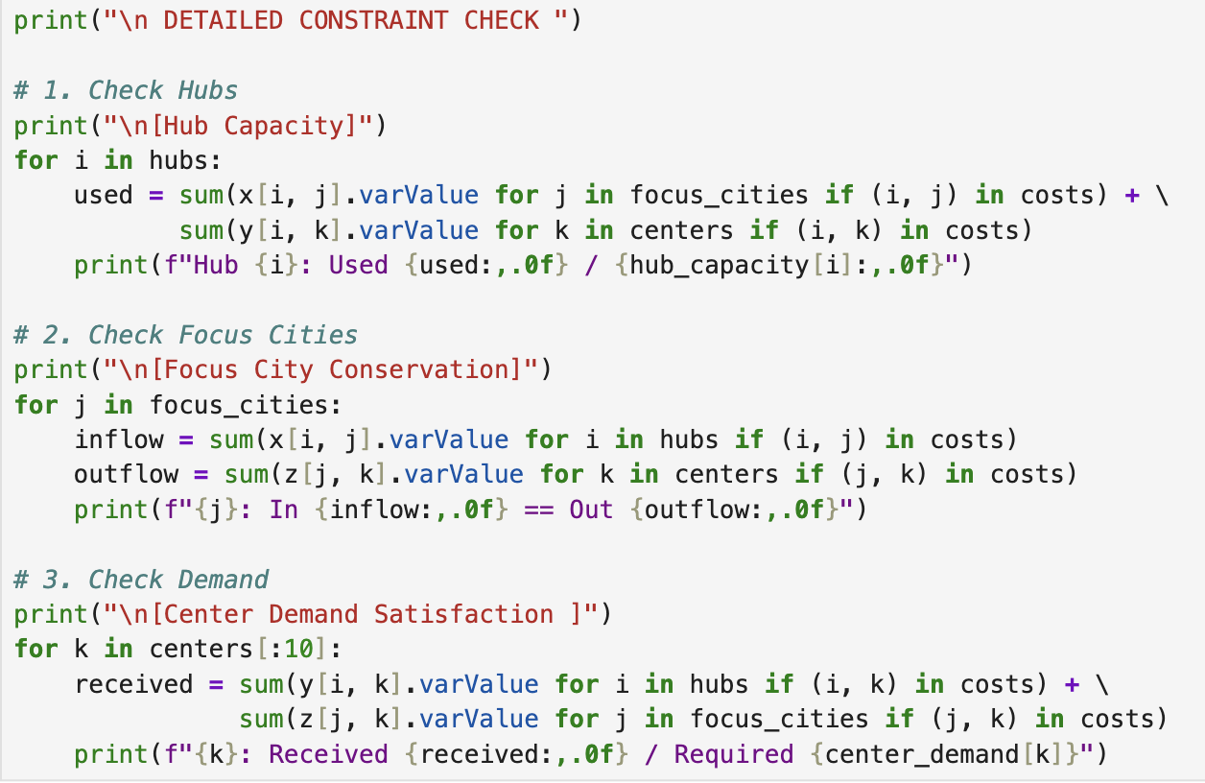

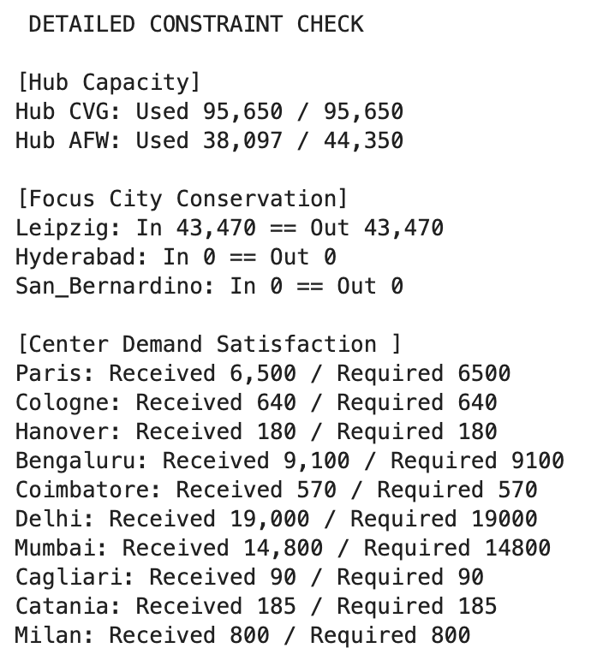

B2: Decision Variables, Constraints and Objective Function

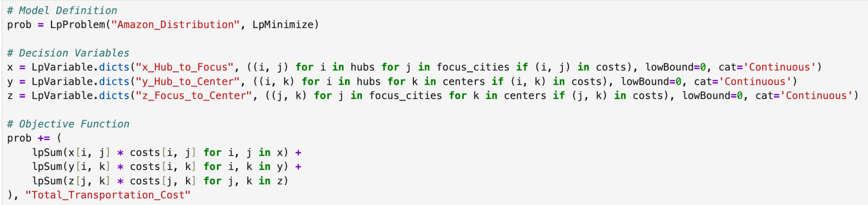
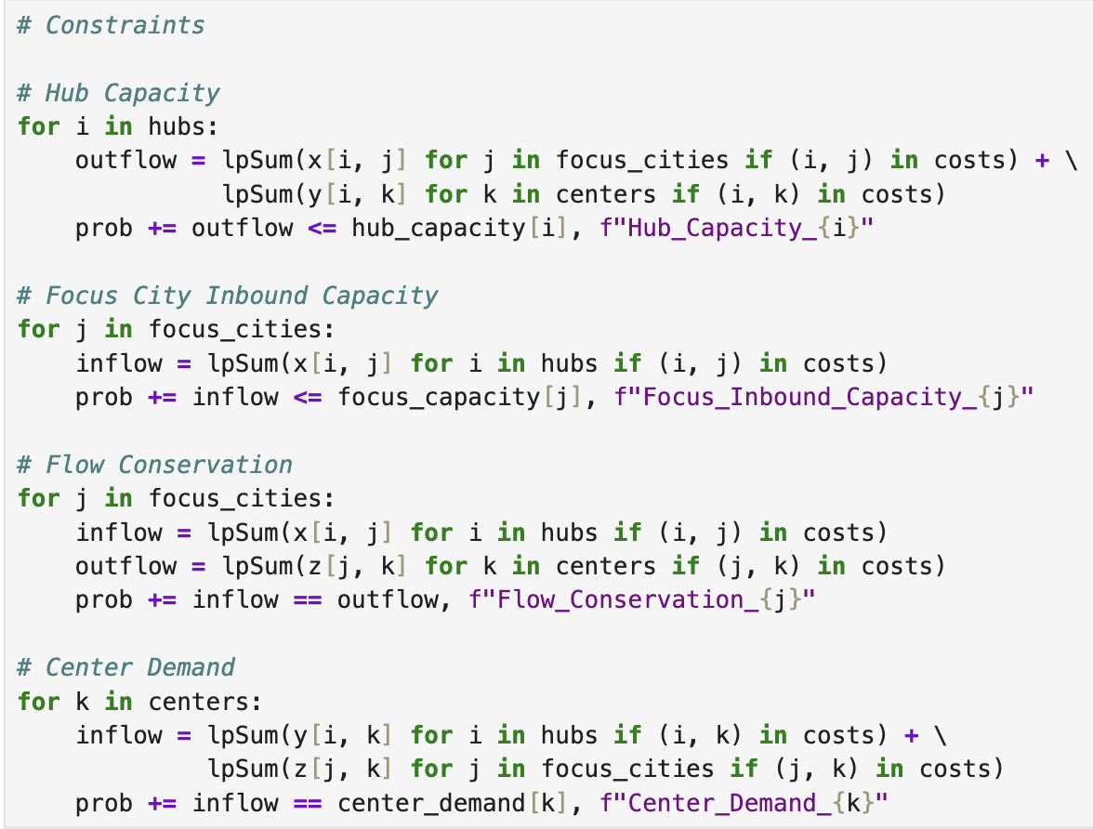

B3. Expected Output Solution

These results align closely with logical expectations for a logistics minimization problem. The algorithm demonstrated a clear preference for shipping directly from Hubs to Centers, which is rational given that direct routes typically incur a single shipping fee rather than the "double handling" costs associated with routing through a Focus City. Despite this, the model routed a significant volume of cargo through Leipzig. This was also expected, as the dataset restricted direct flights from US hubs to many international locations, making Leipzig the necessary bridge for European and Asian distribution. Conversely, the model routed zero cargo through Hyderabad, which matches the data limitations I identified; since Table 2 provided no costs for the inbound leg from US hubs to Hyderabad, the solver correctly treated it as an invalid route and ignored it entirely.

C. Reflection
Going into this implementation, I expected Python to be much easier to manage than Excel, and that proved to be completely true. In Task 2, I noted that Python would be more "scalable," and the difference was obvious when I started coding. Instead of manually selecting cells to create 65 different demand constraints like I would in a spreadsheet, I was able to write a single loop that handled every city at once. This confirmed for me that as logistics networks get bigger, coding is really the only viable option to avoid human error.
The project also threw me a curveball regarding the data. I assumed the model would use all the Focus Cities to spread out the volume, but it completely ignored Hyderabad. I realized later this was because the dataset didn't have a cost listed for flying into Hyderabad, so the solver treated it as an impossible route. That taught me a huge lesson: in optimization, missing data isn't just a blank spot; it acts like a hard wall that forces the model to change its entire strategy. Overall, seeing the code solve this complex problem in a fraction of a second proved just how efficient these tools are compared to manual planning.

Sources

No sources were used besides WGU official course materials.

